Activity 2.3.3 Multiplexers and De-Multiplexers
Introduction
Though it may be hard for you to believe, there was once a day when not everyone had a cell phone. Every house had one phone. That’s right, just one. How was this phone connected to all of the other phones in your town or country? Obviously it isn’t practical to have a wire from your phone connected directly to all other phones individually. This would require an unimaginable amount of wire traveling to and from every home in America. The solution to this problem is for a group of homes to share one wire with another group of homes. This is sharing of a resource and, in this case, the wire is a classic application of a multiplexer/de-multiplexer circuit.

Another classic application of multiplexing/de-multiplexing is the way that seven-segment display signs are wired. In this activity you will implement two simple display signs. The first will not take advantage of multiplexing and the second will.

Equipment
- Circuit Design Software (CDS)

Procedure
- The schematic diagram shown below is designed to display the word OPEN on four seven-segment displays. Though this design works, it is an inefficient use of power. Each segment draws approximately 18 mAmps from a 5V power supply. It takes 21 segments to display the word OPEN. Power = Voltage x Current (P=VI) so each segment is therefore using 90 mWatts of power. To display the word OPEN, a total of 90 mWatts x 21 segments = 1.89 watts of power is required. This may not seem like much power, but consider all of the displays that you see every day. If they were all designed using this technique, a tremendous amount of power would be wasted.
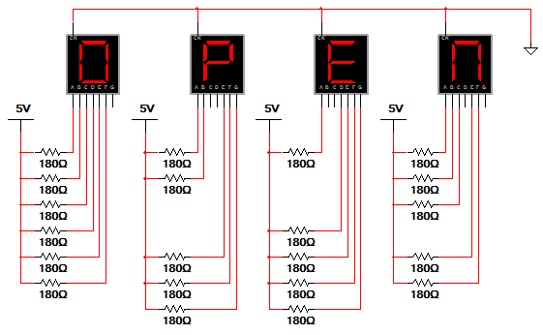

- Using the CDS, enter this circuit and verify that it is working as expected
(i.e., is OPEN being displayed?).

- A significantly better way to display the word OPEN would be to multiplex the seven-segment displays. Thus, for the word OPEN to be displayed properly, the displays must be de-multiplexed. The schematic diagram shown below accomplishes this task by using a 74LS139 2-to-4 de-multiplexer and 2 switches. (In a real application, a counter would replace the switches. Counters will be discussed in Unit 3.) In this implementation only one display is on at any given time, resulting in significantly reduced power usage.

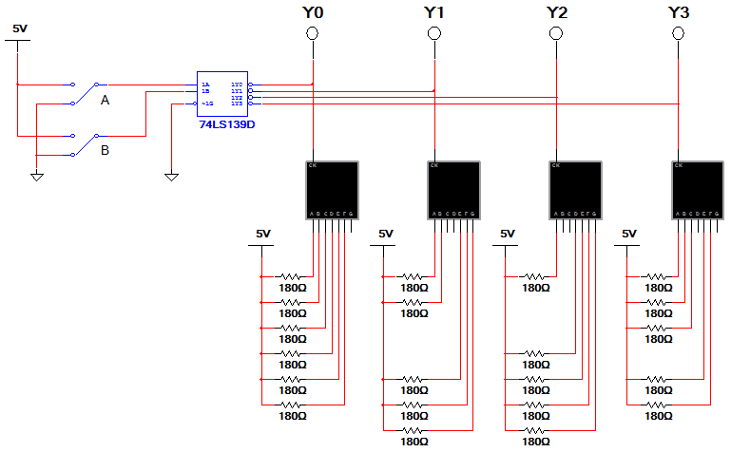

- Using the CDS, enter this circuit and verify that the circuit is working as expected by completing the table shown.

B | A | Y0 | Y1 | Y2 | Y3 | 1st  Display | 2nd  Display | 3rd  Display | 4th  Display
0 | 0
0 | 1
1 | 0
1 | 1

- Use the knowledge gained from implementing the multiplexed version of the circuit that displayed the word OPEN to design a circuit that displays the word HELP.
Print a copy of the circuit and attach it below.

Multiplexed Display HELP
- Using the CDS, enter this circuit and verify that the circuit is working as expected by completing the table shown.

B | A | Y0 | Y1 | Y2 | Y3 | 1st  Display | 2nd  Display | 3rd  Display | 4th  Display
0 | 0
0 | 1
1 | 0
1 | 1

Conclusion
- As discussed in the Procedure, the un-multiplexed version of the circuit that displays the word OPEN uses 1.89 watts of power. On average, how much power does the multiplexed version use? For the sake of simplicity, you may assume that the 74LS139 requires no power.

- The circuit shown below takes the simplification of the circuit that displays the word OPEN to the next level. This circuit uses the same amount of power as the original multiplexed circuit but requires fewer (and differently-sized . . . HINT) resistors.
Explain how this circuit works.

