Activity 1.1.2 Investigating Basic Circuits (DMS)

Introduction
What is an electrical circuit? How can you manipulate components and design a circuit that will do what you want it to? This guided activity will introduce you to some components, tools, and concepts that are fundamental in electronics. It will allow you to investigate and discover:

- What are voltage, current, and resistance? How are they related to one another?
- What are some of the basic components that make up simple circuits and what do they do?
- What are the important characteristics of a circuit and how do I measure different parts of a circuit?
- How do I measure voltage in a circuit?
- How does the arrangement of components affect the characteristics of the circuit?
- How do I work safely with circuits?
- How can I use calculations to design circuits before I start creating one?

Equipment
- Digital MiniSystem (myDAQ and myDigital Protoboard) or breadboard
- (2) - Light emitting diodes (LEDs)
- (2) - 330 Ohm resistors (orange/orange/brown/gold or silver)
- Digital multimeter (DMM)
- #22 Gauge solid wire

Procedure
Follow the instructions to create different types of circuits. As you create each circuit, you will be asked to make measurements and record observations to gain understanding about the circuit and its components. Let us begin by investigating two components that are commonly used in circuits. They are resistors and Light Emitting Diodes (LEDs).
Part A: Creating a Circuit and Measuring a Circuit’s Properties
- A Simple Circuit - Arrange the components according to the picture shown. You will need to plug the USB cable from the myDAQ into your computer to provide power to the Protoboard. Notice that the LED has a flat notch on one side. Make sure the notch is initially oriented on the bottom as shown in the picture. In this arrangement, the flow of conventional current is from the top (5V) to the bottom (0V) through the resistor and the LED. What do you think the role is of the resistor in this circuit?

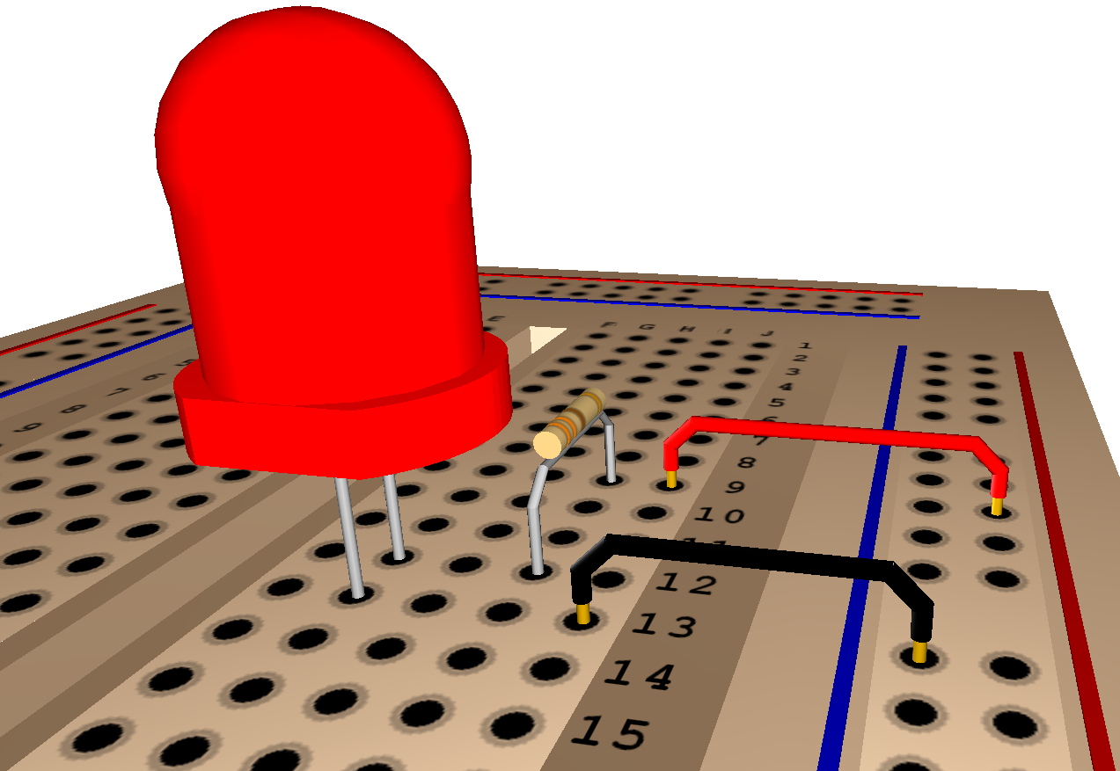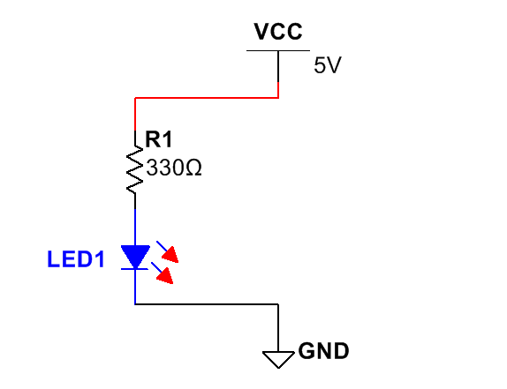
(1a) Components on a Breadboard (1b) Circuit Diagram
In a circuit, the flow of conventional current can be described as a positive charge moving through a complete circuit path (VCC to GND). Can you trace the flow of conventional current in both of the above pictures?
- With the LED illuminated, flip the direction of the LED on the breadboard (notch on top now), and then flip it back to its original position (notch on bottom). What does your observation tell you about diodes (and LEDs)?

- Using the DMM to Measure Values - Making sure that the RED lead is plugged into (V) and the black lead is plugged into (COM) on the myDAQ, open the DMM on your computer. With the Voltage Range set at 60V, select the Direct Current Voltage Measurement Setting and Run (Continuously). Place the RED DMM lead on the top of the resistor and the black lead on the bottom of the LED. Note the reading on the DMM. Now switch the DMM leads.
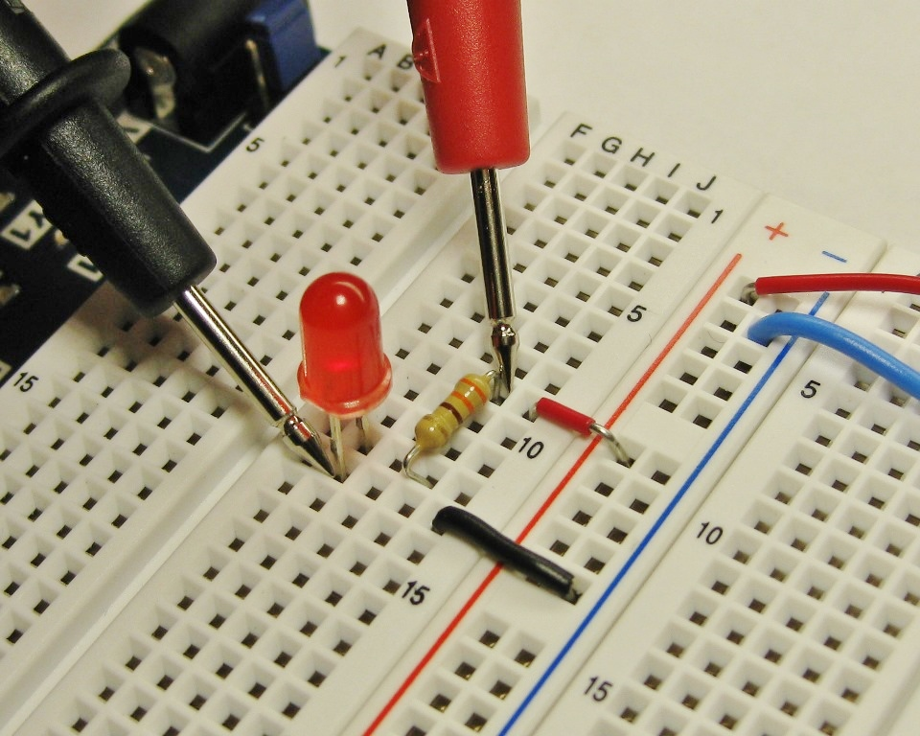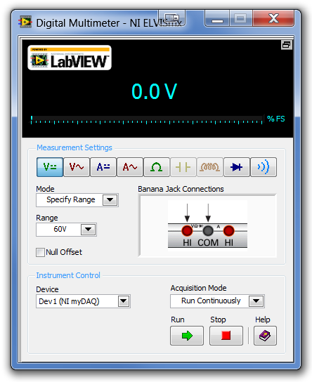
(3a) myDAQ DMM (3b) Reading voltage across the resistor and LED
What did you notice about the value on the DMM when you switched the leads?

- Select the next smallest voltage range (20V) and place the DMM leads across the circuit as you did initially in picture (3b). Note the value on the. What is happening on the display each time you make the range smaller?

- Select the next smallest range (2V). What happened and why? What was the most accurate measurement you were able to make of the voltage across the resistor and LED?

- Set the DMM to the range that will give you the most precise voltage measurement and touch the lead across the two ends of the red wire. Note the reading on the DMM. Now touch the leads across the two ends of the black wire. Note the reading.
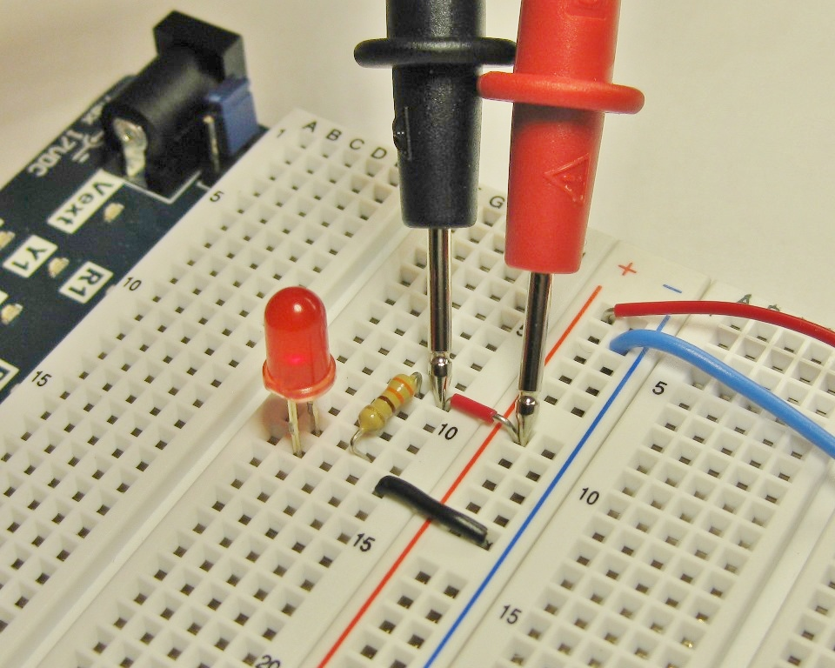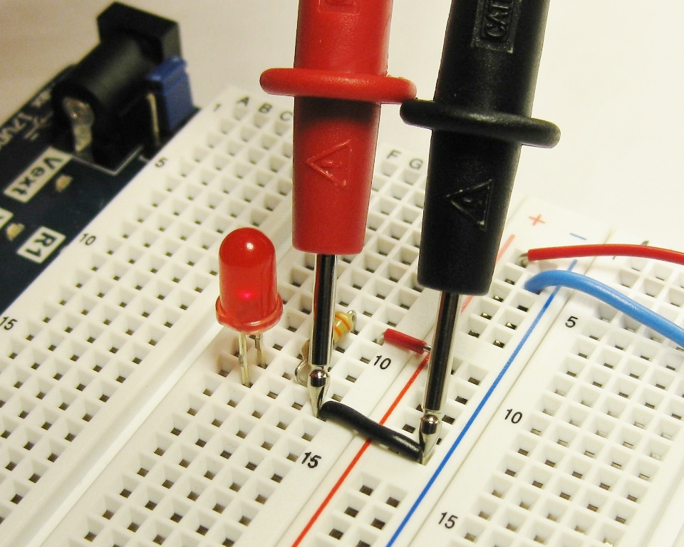
(6a) (6b)
Voltage (ΔV=Vf-Vi) is a description of a component’s potential to do work (1 volt means the component could do 1 joule of work for every coulomb of charge that passes though it (1V= 1J/1C). In order for a component to do work, there must be a difference in the potential across the component to do work (often called a potential difference). Why do you think the reading was the same for both of these sections of the circuit? What you have just observed is exactly why birds can land on high power lines unharmed.

- In Step 3 you measured the voltage across the resistor and the LED combined. Now touch the leads across both ends of the resistor. Note the reading on the DMM. 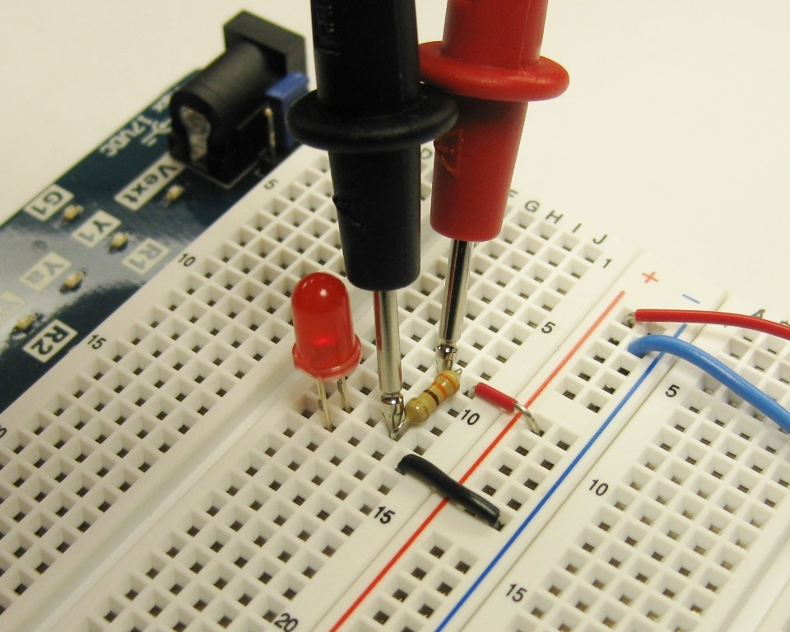
(a) Voltage across LED and Resistor (b) Voltage across Resistor Only

Can you guess the reading you will see when you touch the DMM leads across the LED only? Were you correct? Why did you guess that value?

- You might be asking why we need a resistor in this circuit. Is it doing any work? Some components have limitations on how much electrical current can pass through them or how much voltage they should have across them. We can calculate the relationships between voltage, current, and resistance for a component using Ohm’s Law (V=IR).
Let’s assume the voltage you saw across the 330Ω resistor was roughly 3V when the circuit was active. What is the conventional current (measured in Amps) traveling through the resistor according to Ohm’s Law?

In this arrangement, the electrical current has only one path through the components (top to bottom in the picture). These components can be described as being in series with each other. The amount of current flowing through an LED must each be equal in the same path.
Warning: Do not attempt to verify the current in the circuit at this time using the DMM. While the DMM can handle this amount of current, you must learn how to use the ammeter portion of the DMM properly to protect it from blowing a fuse. Shorting voltage sources is dangerous and can damage the DMM.

Part B: Series and Parallel Circuits
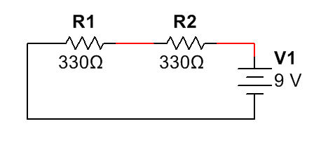
- These two identical 330Ω resistors are in series with each other. There is only one path through the circuit from the power source to the ground. In this diagram, the power source is a 9V battery. One end of the battery has 9V of potential to do work (positive terminal-top). The other end of the battery has zero potential to do work (negative terminal/ground-bottom).
(a) Based on your observations, what would you expect the voltage to read if you touched the DMM across both R1 and R2?

(b) Due to the fact that R1 and R2 are identical, what would you guess the voltage across each resistor is individually? Why?

(c) We can actually replace these two resistors with one resistor that would have the same impact on the circuit. (This theoretical resistor is called an equivalent resistor.) What would the value of this equivalent resistor have to be in Ohm’s (Ω)?

- Create this series circuit on your breadboard with a 5V power source. With both LEDs illuminated, remove one of the LEDs from the circuit path. What happened and why?
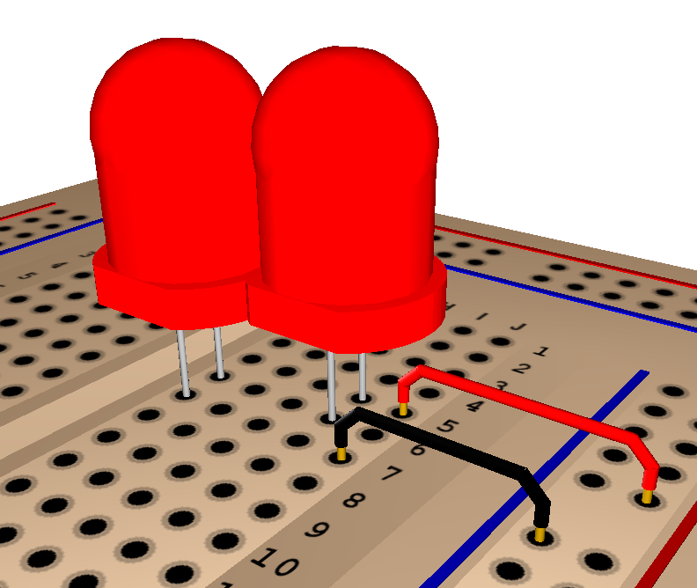
- You can try 3 LEDs in series but none will light up. Why do you think that is?

- Components in a circuit can also be arranged in parallel. Create this parallel circuit on your breadboard. With both LEDs illuminated, what happens if you remove one of the LEDS from the circuit path?
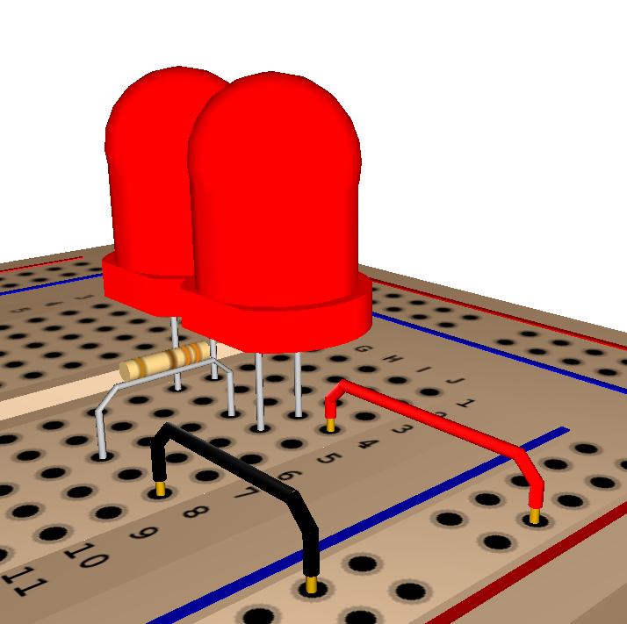

- Using the diagram for a series circuit shown to you in Step 9 as a reference, can you draw a circuit diagram showing 2 resistors in parallel? (Draw circuit below.)

- In a series circuit, all components have the same current (Amps) flowing through them (even if the resistors have different values). That is not the case for components in parallel with each other. What do components in parallel have in common?

- Based on your observations and what you have learned about parallel circuits, use Ohm’s Law (V=IR) to calculate the current in each of the 3 resistors.
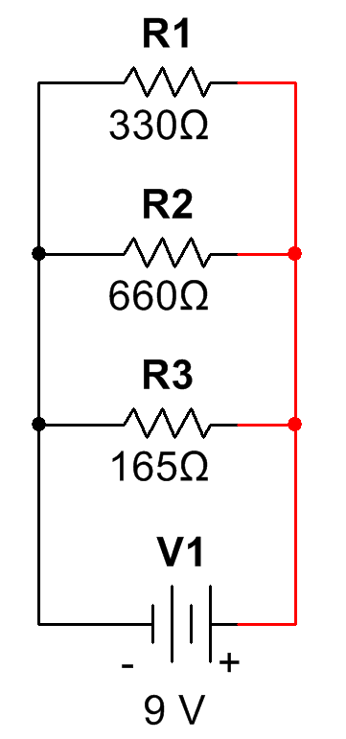
Imagine you add more resistor (R4 and and R5) in parallel. For each new path to the battery you create, what do you think that does to the total amount of current going into and out of the battery?

Conclusion
- Describe the proper way to place the DMM leads and the steps you use to attain the most precise measurement value for voltage across components using a Digital Multimeter (DMM).

- If the value on the DMM is negative, what does that tell you about the orientation of the DMM leads in relation to the flow of conventional current?

- LEDs and resistors transfer electrical energy into light and thermal energy. What is an important characteristic about LEDs (and diodes) that make it unique compared to a resistor?

- In your own words, describe what it means for components to be in series with each other. What characteristic do components in a series always have in common?
(Voltage, Current, or Resistance)

- In your own words, describe what it means for components to be in parallel with each other. What characteristic do components in parallel always share in common?
(Voltage, Current, or Resistance)

Going Further
- In this investigation you were introduced to the idea of equivalent resistance (replacing multiple resistors in a series with one that does the same job. Equivalent resistance for series circuits can be shown as a simple mathematical expression. How would you express this relationship to the total resistance in the circuit mathematically?
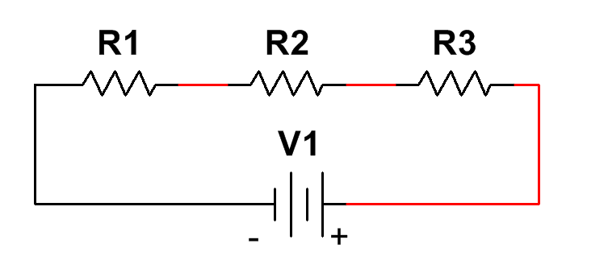

- A theoretical equivalent resistor can be placed in parallel circuits and shown mathematically as well. This relationship is a little less straight forward than equivalent resistance in series circuits. With a little research, can you determine how the equivalent resistance for this parallel circuit would be expressed mathematically? We will expand our understanding on these concepts in later activities.

